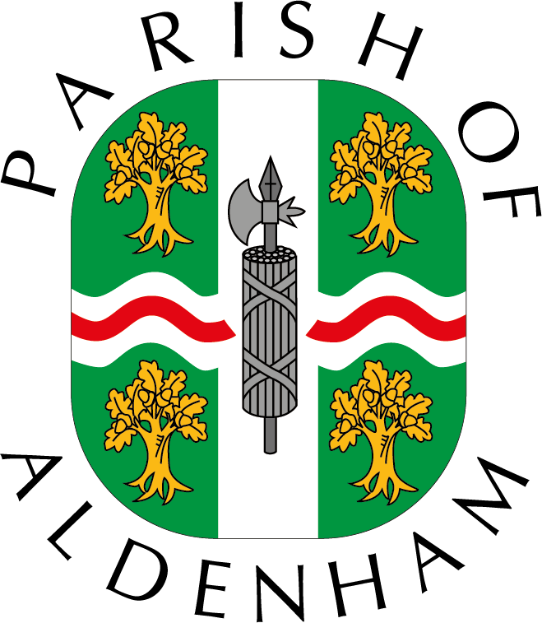

ALDENHAM PARISH COUNCIL

Small Community Grants Scheme

Aldenham Parish Council aims to operate a modest grant aid system each year.
Applications are considered by the Finance and General-Purpose Committee.

The maximum grant funding available per applicant is £1000 per year.

The system aims to:

- Help the parish’s voluntary groups to improve their effectiveness.
- Help to ensure the provision of services needed by the residents via the voluntary sector
- Support organisations and in some cases individuals which meet the needs of people experiencing social and economic difficulties and
- Ensures that there is equality of access and opportunity for all residents to the services and funds it provides

The Parish Council values the diversity and strengths of the local voluntary sector and acknowledges its independent role in the community as:

- A source of valuable services.
- A means of enabling people to work together.
- A channel for campaigning and advocacy

The Parish Council defines a voluntary group as a ‘not-for-profit’ organisation, set up and run by a voluntary, management committee.

This document gives the Parish Council’s general funding principles and details its expectations of all groups and individuals in receipt of grant aid.

GUIDELIONES & CRITERIA

- Grants will normally be given only to individuals and organisations resident in or serving the area within the parish of Aldenham (which includes Radlett , Letchmore Heath , Aldenham , Round Bush and High Cross. )
- Grants should represent assistance to projects of local use and need to show a clear benefit to local residents.
- Grants are normally made for one year’s expenditure at a time and should be spent within the year for the purpose for which they were given. They should not be added, wholly or partly, to reserves unless part of a previously approved programme of funding for a particular project.

- Normally, grant applications from organisations will only be considered when accompanied by at least one of the following:
1. Audited accounts; or
2. Accounts that have been subjected to independent inspection as required by the Charities Act or, where the organisation is newly formed, a case for funding including supporting evidence of fund-raising efforts

- Grant applications from individuals will be considered providing grants have:
- Charitable or educational purposes linked to recognised bodies acceptable to the Council.
- Are seen to be of local benefit, for example through information dissemination or are likely to encourage inspiration and motivation to the applicant's peer group.
- Only one grant award per year will be made to each applicant
- The Council will not normally award grants for day -to-day running/operating costs
- Grants may be made to religious organisations where the project is aimed at the wider community and it to the benefit of all residents of the parish

Applicants may be required to return grant-aid if they close, or if a project or services funded by the Council, is not satisfactorily provided.

Voluntary groups grant-aided by the Council are required to:

- Ensure efficient levels of administration, hold regular meetings, keep minutes and circulate information to group members
- Any organisation which applies for grant funding must have a written Constitution which has been formally adopted by its members. It must also have a bank account in its own name, with two authorised representatives to sign each cheque.
- Organisations applying for grants must provide audited accounts or accounts that have
been independently examined by a suitably qualified person for the previous two
financial years. Newly-formed organisations must provide a comprehensive budget and business plan.
- Report back as required to the Council on their activities, and a final statement of progress made against the aims specified in the grant application must be submitted to the Council before the end of the financial year in which the grant was awarded
- Involve group members and users in policy-making and in the management of activities and services
- Establish and monitor equal opportunities policies and practices
- Meet the legal responsibilities of an employer where appropriate; adopt, implement and monitor good employment practices and procedures
- Recruit and support volunteers where appropriate
- Acknowledge the Parish Council’s support in annual reports.
- In case of individuals, the Council will require a report of the project or other agreed method of verifying the use for which the application of grant was made.

This policy was adopted by Aldenham Parish Council at its meeting of 13 June 2022 and will be reviewed per the matrix agreed by the F&GP Committee

